**Nathan C. Harris, Thomas M. Jahns, Surong Huang**

University of Wisconsin-Madison

The authors thank Prof. T.A. Lipo at the University of Wisconsin – Madison for his valuable consultations regarding the machine designs

**2002**

Integrated Motor/Controller Drive for Automotive Water Pump Application

No hardware, No modularization

500W, 42VDC, 5000rpm

5 brushless machine topologies are discussed. Interior PM synchronous m/c is selected

Six-switch PWM voltage-source inverter, power MOSFETs, integrated power electronics module (IPEM)

On PE side, physical layout, thermal management and EMI filter design are discussed

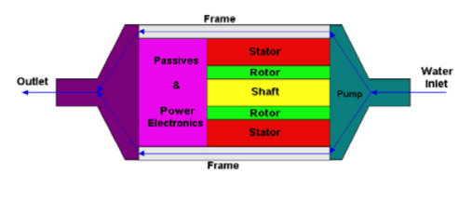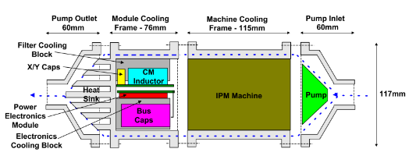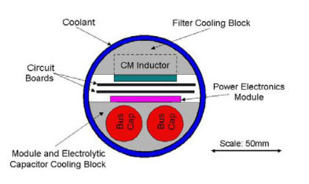

**Stephanie I. Mueller – MSc Thesis**

UNIVERSITY OF WISCONSIN – MADISON, Professor Greg F. Nellis

**2005**

Model and Design of an Air-Cooled Thermal Management System for An Integrated Motor/Controller

Modular permanent magnet machine, integrated power electronics module (IPEM), experimental verification

E core ile test etmiş ?

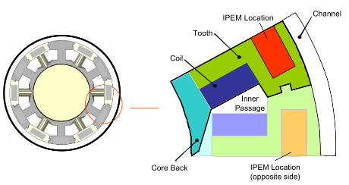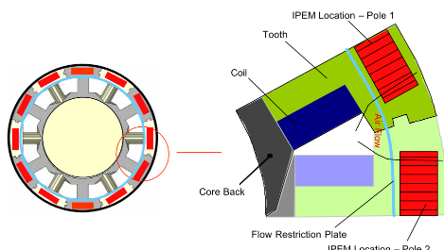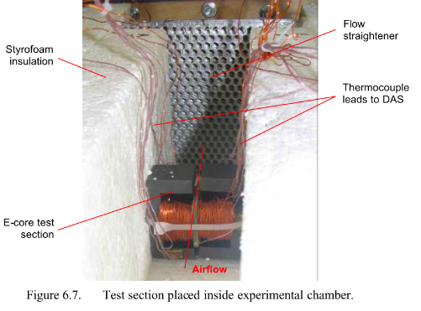

**Suman Dwari, Leila Parsa, and Thomas A. Lipo**

Department of Electrical, Computer and Systems Engineering, Rensselaer Polytechnic Institute, Troy, NY 12180 U.S.A.

Department of Electrical and Computer Engineering, University of Wisconsin – Madison, Madison, WI 53706 U.S.A

**2007**

Optimum Control of a Five-phase Integrated Modular Permanent Magnet Motor Under Normal and Open-Circuit Fault Conditions

Simulation results, FEA, 5-phase

Integrated Modular Permanent Magnet Motor Drive (IMPMMD)

The torque pulsation has been decreased significantly

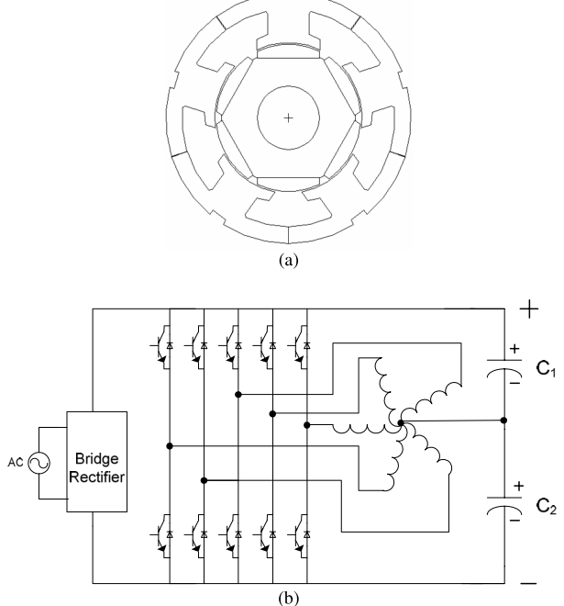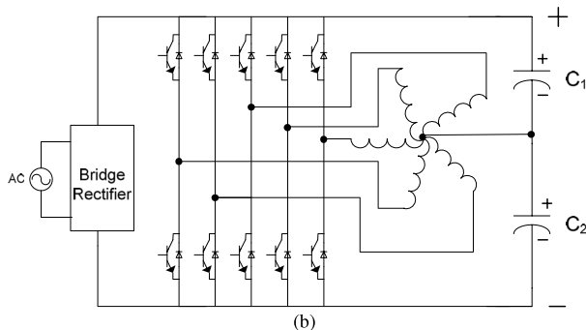

**Wen Ouyang, Nicholas Lemberg, Ruoping Yao*, T.A.Lipo**

Department of Electrical and Computer Engineering University of Wisconsin-Madison

Department of Electrical Engineering* Shanghai Jiao Tong University 1954 HuaShan Road Shanghai

**2007**

A Novel Modular Permanent Magnet Drive System Design

Soft magnetic composites (SMC), flexible design options in 3D

Five-phase Modular SPM Motor, simulation results

The experiment setup work is still under way. The test results will be provided in the future report

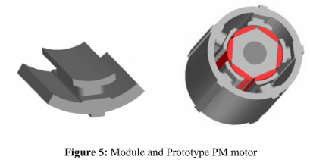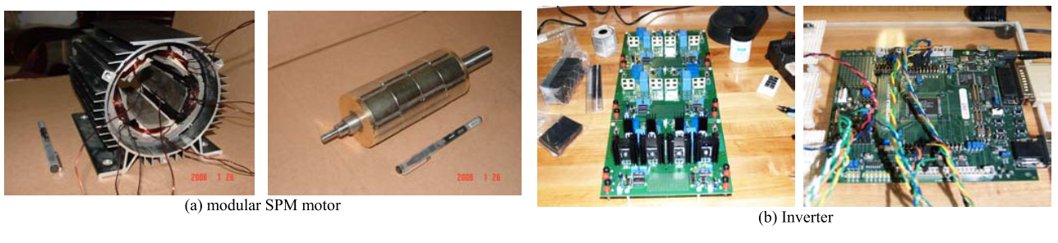

**R. J. White, T.M. Jahns, and T.A Lipo,** “**Fault management techniques for an integrated modular motor drive,**” in Proc. of 2005 CPES Power Electronics Seminar, Blacksburg, VA., Apr. **2005**, pp. 581-588.

**N.R. Brown, T.M. Jahns, R.D. Lorenz**

Wisconsin Electric Machines and Power Electronics Consortium Department of Electrical and Computer Engineering University of Wisconsin - Madison Madison, WI 53706, USA

**2007**

*Power Converter Design for an Integrated Modular Motor Drive*

Five-phase machine, soft magnetic composite (SMC) material, six-pole surface PM rotor

2.7 kW, outer diameter is 120 mm, 400V dc bus, DC bus interconnections effect

hard-switched half-bridge inverter phase-leg consisting of two IGBTs and anti-parallel diodes, 10kHz

DC bus capacitor, size requirement, experimental results with RL load, GMR sensors

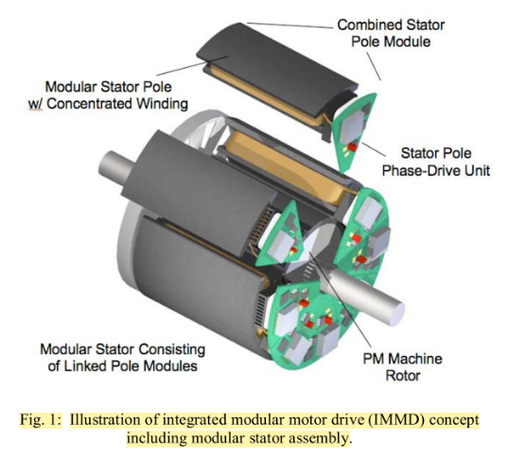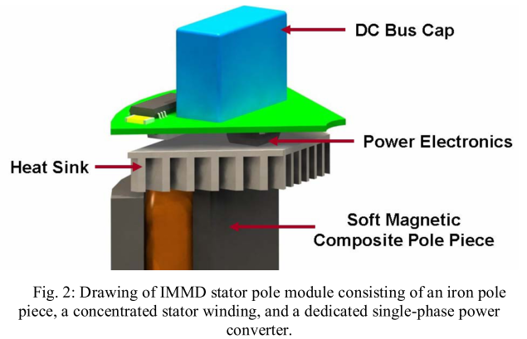

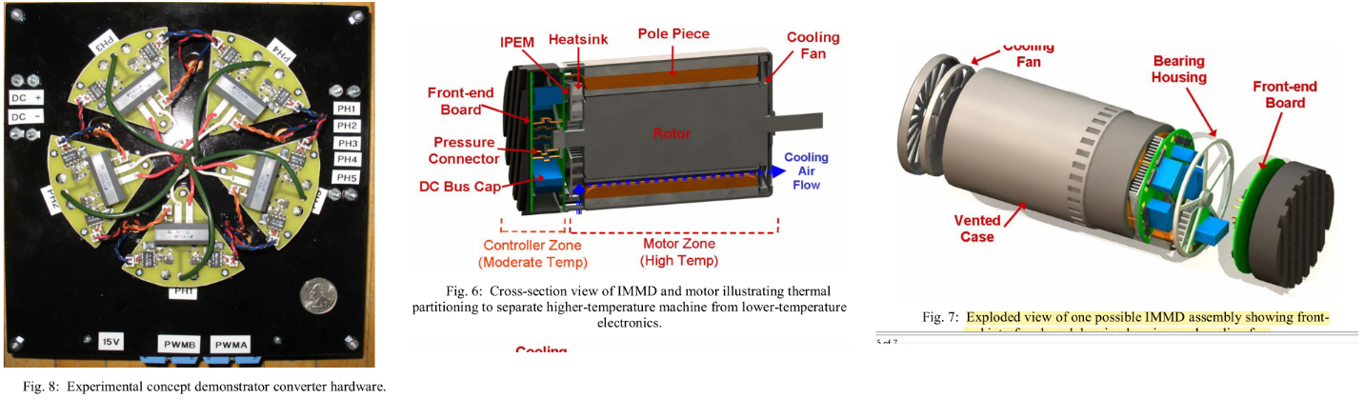

B. J. **Sykora**, “**Development of a demonstrator model of an integrated modular motor drive**,” **M.S. thesis**, Dept. of Electr. and Computer Eng., **University** **of** **Wisconsin**- **Madison**, Madison, US, **2008**

*Sykora, B. J., Jahns, T. M., and Lorenz, R. D., “Development of a Demonstrator Model of an Integrated Modular Motor Drive,” in Proc. 2008 NSF-CPES Annual Conference, Blacksburg, VA, April 2008.*

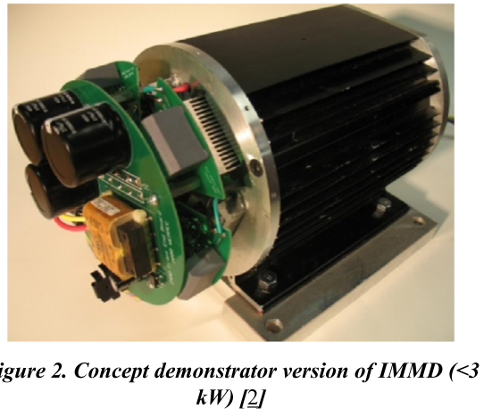

**Gilsu Choi1, Zhuxian Xu2 and Ming Li2, Shiv Gupta1 and Thomas Jahns1, Fred Wang3, Neil A. Duffie1, Laura Marlino4**

Univ. of Wisconsin – Madison1, Univ. of Tennessee – Knoxville2, Univ. of Tennessee and ORNL3,  
Oak Ridge National Laboratory4

**2011**

*Development of Integrated Modular Motor Drive for Traction Applications*

Review of alternative concentrated winding PM machine configurations, Slot/pole combinations, SMC

Most promising controller architecture for providing a high-level of fault tolerance and robustness

A 10 kW phase-leg package using Si IGBT power devices combined with a 2-pass-tube coldplate is proposed that shows promise for holding the junction temperatures below 200°C with an ambient temperature of 150°C., IGBT switching experiments, thermal simulations

The results of these analytical and experimental studies have succeeded in setting the stage for developing a 10 kW preliminary prototype integrated motor drive during the coming year.

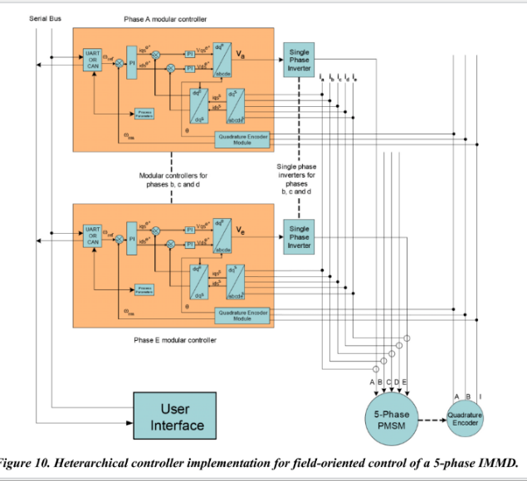

**Adam Shea T.M. Jahns**

Wisconsin Electric Machines and Power Electronics Consortium (WEMPEC) Electrical and Computer Engineering University of Wisconsin - Madison Madison, WI, USA

**2014**

*Hardware Integration for an Integrated Modular Motor Drive Including Distributed Control*

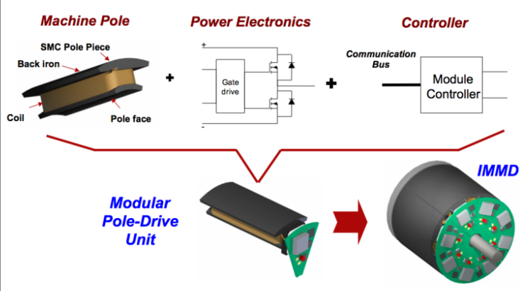 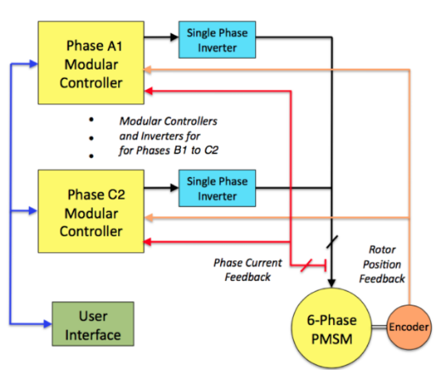

This was the first IMMD prototype unit that included a dedicated controller in each module.

Second generation

18kW (peak), 6-phase IMMD demonstrator unit for a traction drive

* Heterarchical distributed control strategy
* Need for cooperation among the individual controllers
* Maximizing the independence of each controller for purposes of reliability and fault tolerance
* Master/sla ve control configuration

Half-bridge inverter phase-leg for each phase with two discrete 600V IGBTs in TO-247 packages. The nominal dc bus voltage is 325 Vdc.

Cooling for each phase-leg module is accomplished using an off-the-shelf copper pin-fin waterblock designed for graphics card cooling.

This control board is designed with 4 layers of copper traces. The bottom two are solid planes that form the dc-link buswork for the phase-drive unit while also creating a very low-inductance 1nF capacitor. The top two layers contain the DSP controller, analog signal conditioning for voltage and current sensing, gate drivers, and communications interfaces.

The dc-link bulk capacitance is a 20µF film capacitor mounted below the controller on each module. Middle-range frequencies are decoupled using a pair of 22nF ceramic capacitors mounted very near the dc link terminals of each power module.

The gate drive consists of a simple bootstrap driver for the high-side IGBT switch with a matching power driver for the low-side switch. A voltage-clamped version of the half- bridge output node voltage is fed back to the controller in order to provide the necessary feedback for IGBT desaturation protection.

High-bandwidth (~10kHz) current sensing is provided by a linear Hall effect sensor mounted to the bottom of the control board. This sensor measures the field produced by current flowing in the machine phase conductor mounted directly below it. The sensor is shielded from the machine by both the stainless-steel baseplate for low frequencies and by the copper face of the waterblock for higher frequencies.

Position sensing in this demonstrator unit is accomplished using a standard quadrature encoder. The angular position information is delivered in parallel to all six phase-drive controllers. It is recognized and acknowledged that this position sensor represents one of the key remaining vulnerabilities to single-point failures.

Module-to-module communications are handled by both analog signals for current sensing and a CAN bus. The CAN bus, encoder interface, and controls power supply are isolated from the power circuit by means of an isolated dc/dc converter in each module and optical isolation for the signal lines.

For grounding purposes, the controls are all connected to the negative rail of the dc bus in each module, providing a single common reference point.

In order to allow coolant to be shared between the machine and drive, IGBTs rated for a maximum junction temperature of 175°C were chosen along with capacitors rated at 125°C and a high temperature DSP controller rated at 140°C. Simulations of full-power operation predict a 5°C margin when operating with 100°C coolant for these components.

10kW surface six-phase variant of a three-phase fractional-slot concentrated winding permanent magnet (PM) synchronous machine (12/10).

The presence of two wyes makes it possible to shut one down one three-phase inverter and continue operating with half of the machine excited under fault conditions.

If excitation is removed from one of the wyes, the remaining three excited phases are distributed evenly around the stator’s periphery, minimizing unbalanced radial forces on the rotor that can stress the rotor bearings.

A stainless-steel backplate is mounted between the machine and the drive electronics to shield the electronics from fringing magnetic and electrical fields radiated by the machine.

**Test:**

* Constant-V/Hz operation at 200Hz (2400r/min) under no-load conditions
* A basic sine-triangle PWM algorithm is used for the voltage modulation with a switching frequency of 20kHz and a modulation index value of 0.95.
* The drive is operating with a reduced dc link voltage of 110V
* Current and voltage waveforms, hall effect sensor frequency test

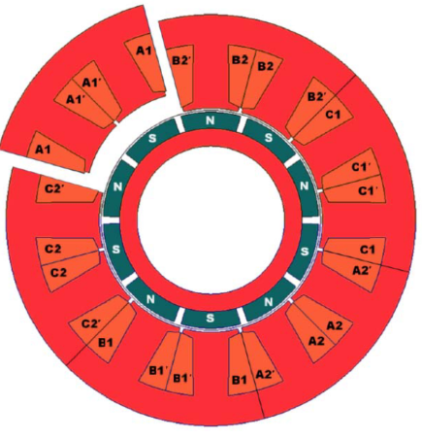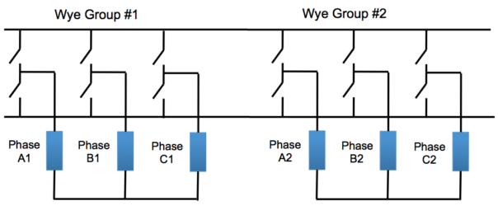

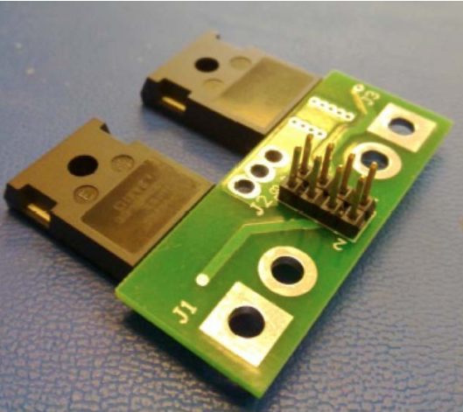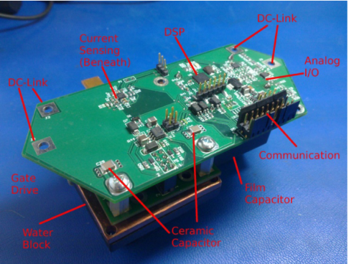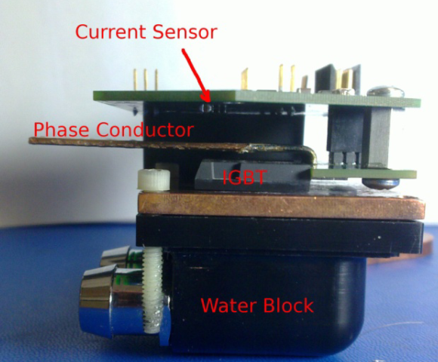

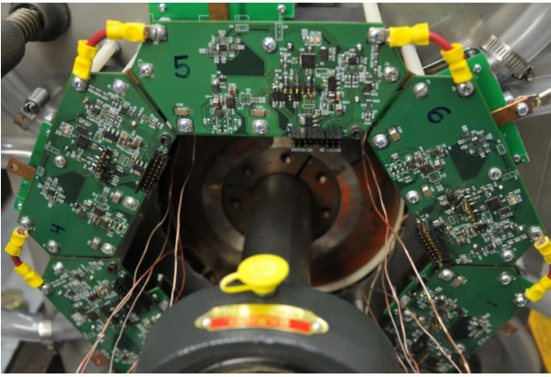

**Adam Shea**

Wisconsin Electric Machines and Power Electronics Consortium (WEMPEC) Electrical and Computer Engineering University of Wisconsin - Madison Madison, WI, USA

**Master Thesis - 2014**

*Hardware Design of a Integrated Modular Motor Drive (IMMD)*

May be an older version. Seems to be with the same content as the above paper.

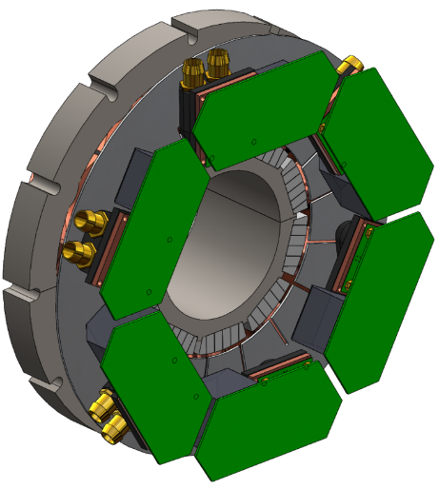

**A. Shea and T. M. Jahns**, “**Control challenges and mitigation tech- niques for sensor errors in modular motor drives with weakly-coupled distributed control architectures**,” in **2015** IEEE International Electric Machines & Drives Conference (IEMDC), Coeur d'Alene, ID, 2015, pp. 890-896

**Jiyao Wang, Ye Li, Yehui Han**

Dept. of Electrical and Computer Engineering University of Wisconsin- Madison Madison, WI, USA

**2013**

*Evaluation and Design for an Integrated Modular Motor Drive (IMMD) with GaN devices*

Series-connected inverter segments, wide bandgap 200V GaN MOSFETs

Eliminating inverter heat sink and optimizing the choice of DC-link capacitors, interleaving

Keep the height of capacitors within 1 inch, capacitor selection and comparison (AEL, Film, Ceramic)

Active DC link balancing

Experiment: 180Vdc, 7Arms, 36uF, 0.6inch height, 3 inch radius, RL load test

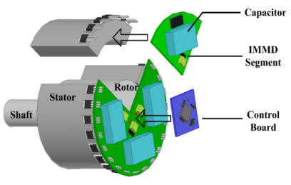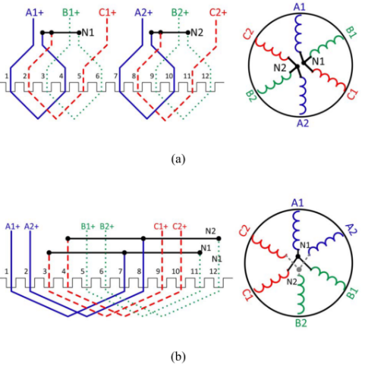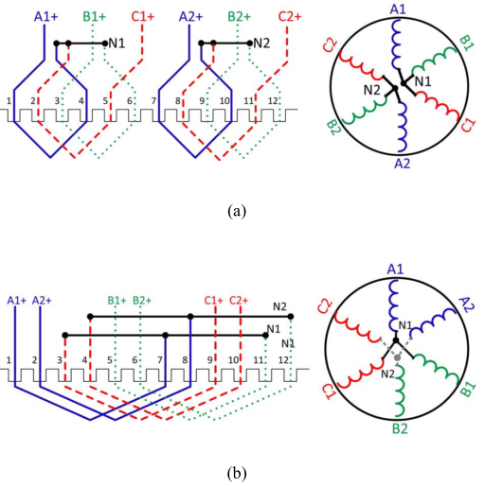

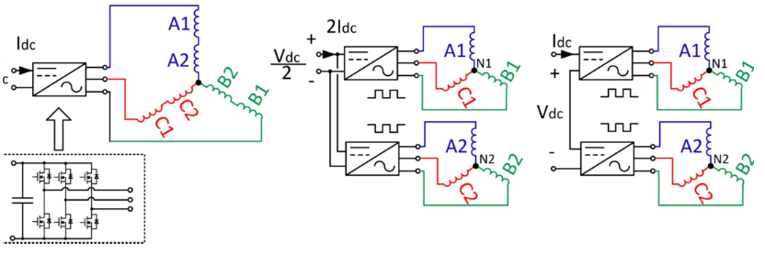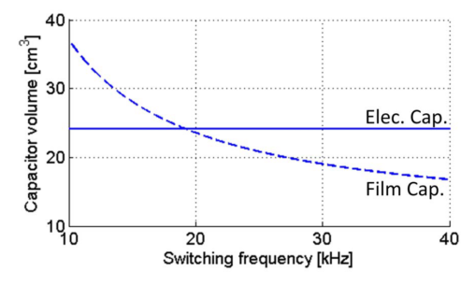

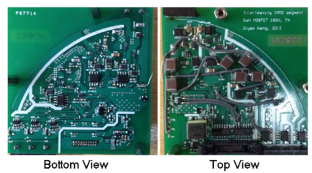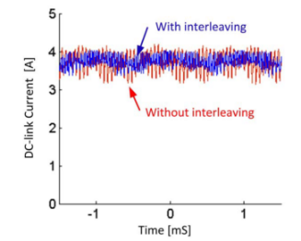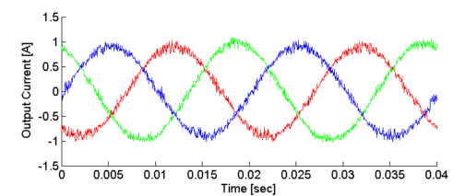

**Jiyao Wang, Yehui Han**

Dept. of Electrical and Computer Engineering University of Wisconsin- Madison Madison, WI, USA

**2014**

*A New Concept of Multilevel Converter Motor Drive with Modular Design and Split Winding Machine*

3-level NPC, 3-level FC, 2n+1-level CHB. A new multilevel converter topology

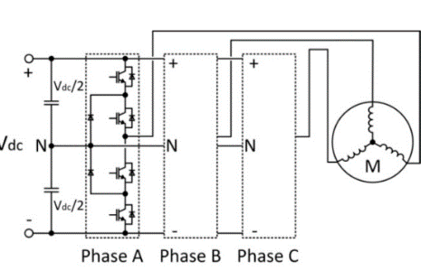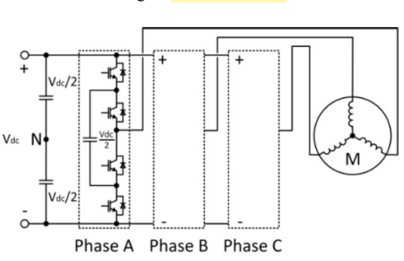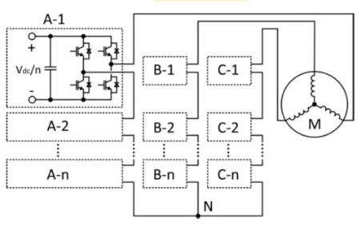

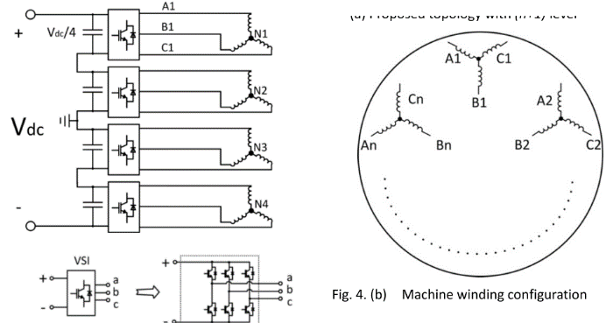

**Advantages:**

* Significant reduction in component quantity. does not require any extra capacitors, diodes or isolated voltage sources.
* Unlimited flexibility and performance optimization, can accommodate a wide range of voltage levels and power ratings, allowing for the use of low-voltage, less-expensive devices.
* Compatibility with different systems. The proposed topology can be supplied by either a single dc source, or several dc sources to power each module.
* Modular design. All inverter modules are identical. Manufacturing cost reduction, faster product development, easy maintenance, and simple construction. The proposed topology has identical gate signal commands for each module (with a phase-shift for interleaving)
* Release of insulation burden and extended service life. The common mode voltage and differential mode output voltages on insulation layers are reduced to to Vdc/n.
* Reduction in capacitor size. The capacitor size can be further reduced by the interleaving technique.
* Better fault tolerance. The proposed topology has access to the voltage and current of each machine winding enabling detection of machine faults quickly and accurately through measurement of winding voltages.
* The **disadvantage** of the proposed topology is the increased number of machine leads

Machine split winding, Gate signal interleaving, Voltage balancer. PSD söylememiş ???

Simulation: 2 modules, MATLAB/Simulink, 200Vdc, 30kHz, 1mF each, 2 A Iq

Experiment: 2 modules, 1.5kW, m/c, 200Vdc, 25kHz, 54uF each, 750rpm, 36 slot induction

In experiment, a 3-lead, 3-phase, 4-pole induction motor is rewound into a 6-lead 3-phase motor

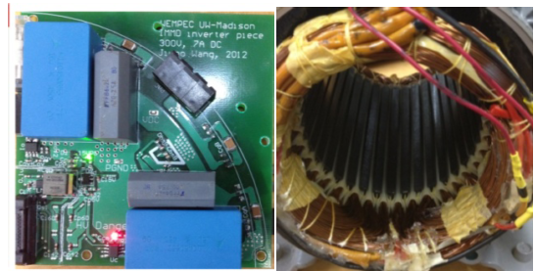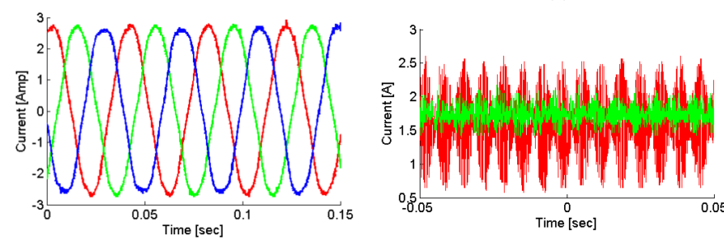

**Yehui Han**

Dept. of Electrical and Computer Engineering University of Wisconsin- Madison Madison, WI, USA

**2014**

*Design, modeling, and control of multilevel converter motor drive with modular design and split winding machine*

Bi sürü topolojiden bahsetmiş, Öncekilerin aynısı.

MV inverter topology, Multilevel topology: two pole pairs, four pole pairs. Hexagram multilevel

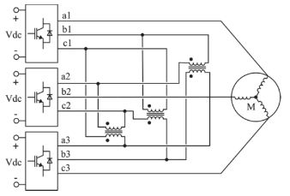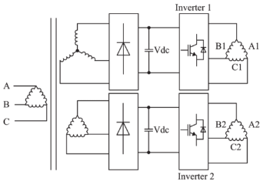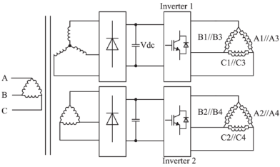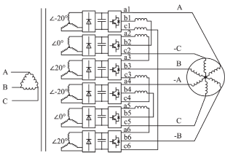**Proposed:**

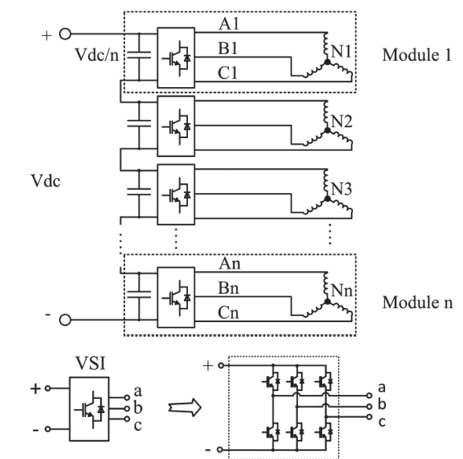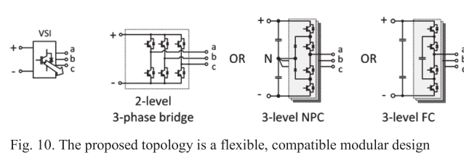

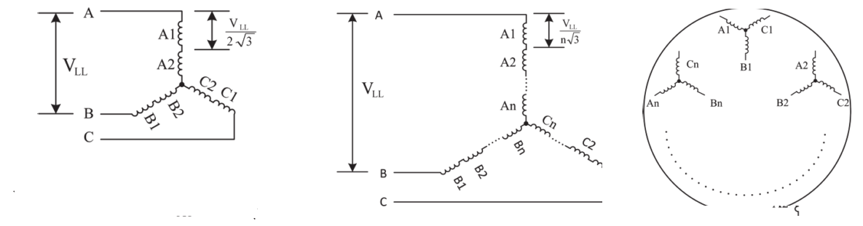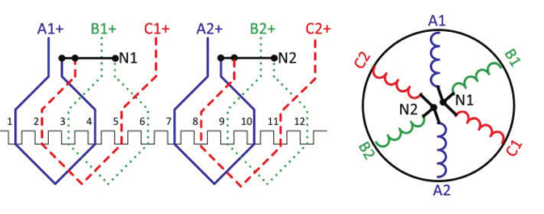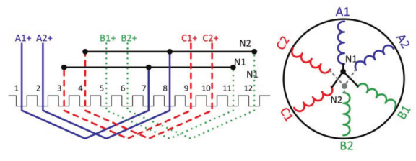

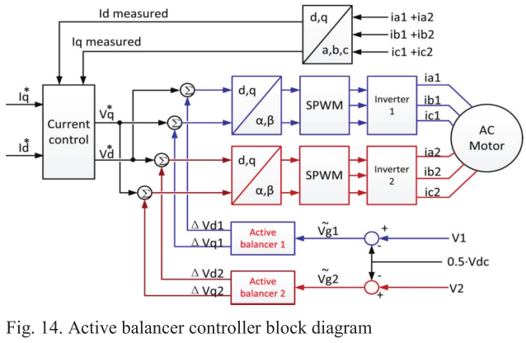

Experiment: RL load

Two inverters, 150V, 3A each, 36uF, inverter radius: 3 inch, converter height: 0.6 inch

%35 reduction in the DC link current ripple

Motor ile de test yapılmış (rewound induction)

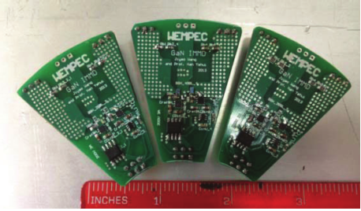

**Wang, J., & Han, Y. (2015).** A Class of Modular Multilevel Motor Drives with Design Flexibility and Reduced Components Number. *Applied Power Electronics Conference and Exposition (APEC), 2015 IEEE*, 2387–2393.

**J. Wang, Y. Li, and Y. Han,** "**Integrated modular motor drive design with GaN power FETs," in IEEE Transactions on Industry Applica- tions**, vol. 51, no. 4, Jul.-Aug., **2015**, pp. 3198-3207.

**Doktora tezi.** **Wang, J. (2015).** Design of Multilevel Integrated Modular Motor Drive with Gallium Nitride Power Devices. *Thesis*.

**Christian Klumpner, Peter Nielsen, Ion Boldea, Frede Blaabjerg, Paul Thargersen**

Institute of Energy Technology, Aalborg University, Denmark, Danfoss Drives

**2002**

Matrix Converter Motor (MCM) for Industry Applications

First integrated regenerative frequency converter motor for industry applications, based on a matrix converter topology.

4-kW matrix converter motor prototype

No modularization, IGBT-diode

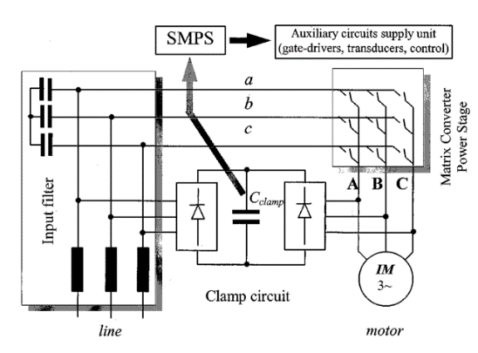 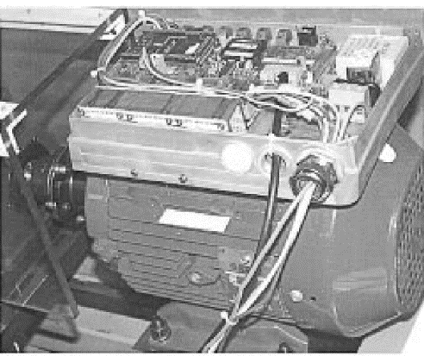

**2003**

*Converter Topologies the Next Generation of Integrated Motor Drives*

ASD converter topologies (inverter is the same, rectifier and dc link/passive sides are different)

No modularity, no hardware

*Evaluation of the Converter Topologies suited for Integrated Motor Drives*

Same with above

**Y Shakweh, G H Owen, D J Hall, H Miller**

FKI Industrial Drives Ltd, UK

**2002**

PLUG AND PLAY INTEGRATED MOTOR DRIVES

IMDs technology, customer’s concerns, market status, future trends as well as technical challenges to increase power ratings.

Today, IMD technology offers power output up to 7.5kW.

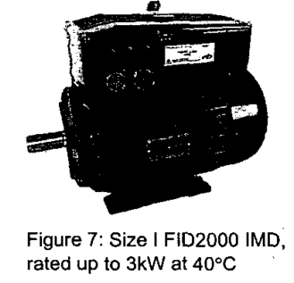

**J. Ranneberg, Y. Tadros, U. Schäfer**

DaimlerChrysler AG, Research and Technology, University of Stuttgart, Germany

**2004**

Motor-Integrated Circular Converter for Hybrid Electric Vehicles

Inserted in the stator housing around the end windings of the induction motor

200-400V, 50kW, IGBT, water cooled, No modularization, toroidal foil capacitor

Prototype 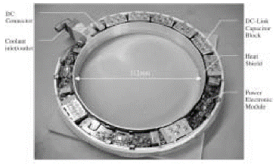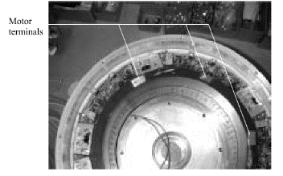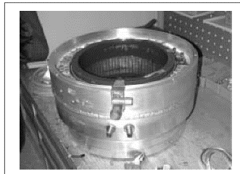

**Francesco Farina, Daniele Rossi, Alberto Tenconi, Francesco Profumo, Stefan E. Bauer**

POLITECNICO DI TORINO, Italy, INSTITUTE FORPOWERELECTRONICS AND ELECTRICAL DRIVES, AACHEN UNIVERSITY, Aachen, Germany

**2005**

Thermal design of integrated motor drives for traction applications

25 kW SRM, water cooled square housing, IGBT based, Comsol simulations (2D FEM)

Integrated Propulsion MOTors (IPMOTs), pre-prototype is under construction

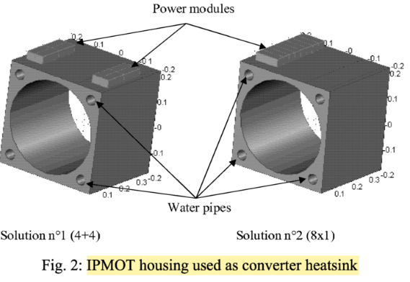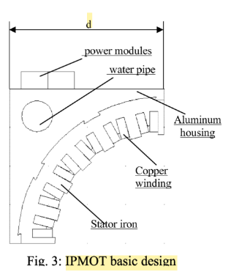

**Alberto Tenconi, Francesco Profumo, Stefan E. Bauer, and Martin D. Hennen**

Dipartimento di Ingegneria Elettrica, Politecnico di Torino, 10129 Turin, Italy

Durotron, 51109 Cologne, Germany

Institute for Power Electronics and Electrical Drives, RWTH Aachen University, Aachen, Germany

**2008**

*Temperatures Evaluation in an Integrated Motor Drive for Traction Applications*

Liquid-cooled totally integrated drive unit Integrated Propulsion MOTor (IPMOT), 24-kW

Four-phase switched reluctance motor (SRM), IGBT based

Simulations (FEM) and thermal experimental setup

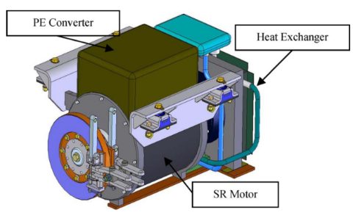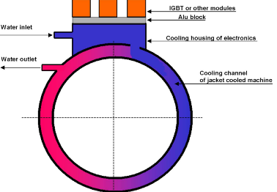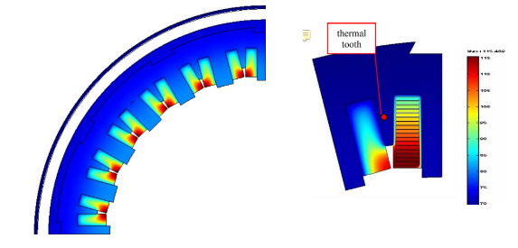

**Martin D. Hennen, Markus Niessen, Christian Heyers, Helge J. Brauer, RikW. De Doncker**

Institute for Power Electronics and Electrical Drives, RWTH Aachen University, Aachen, Germany

**2012**

*Development and Control of an Integrated and Distributed Inverter for a Fault Tolerant Five-Phase*

*Switched Reluctance Traction Drive*

Five phase, Outer-rotor direct drive, 67kW, 750rpm, outer rotor 320mm, Ns/Nr 20/16

Railway traction applications, 400V dc link, 30A phase current, 3.4kW, 33 uF, 10kHz

The communication, as well as the generation of the switching signals, overcurrent protection, etc., is realized on a complex programmable logic device (CPLD) on each pole module

The predictive PWM- based direct instantaneous torque control (PWM-DITC), multiphase torque sharing algorithm

Fault tolerance analysis: torque ripple, unbalanced magnetic pull, vibration shapes

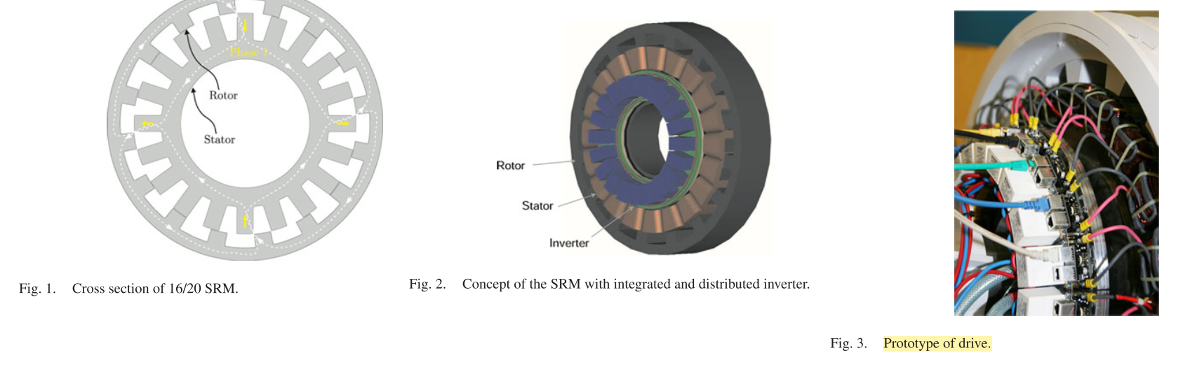

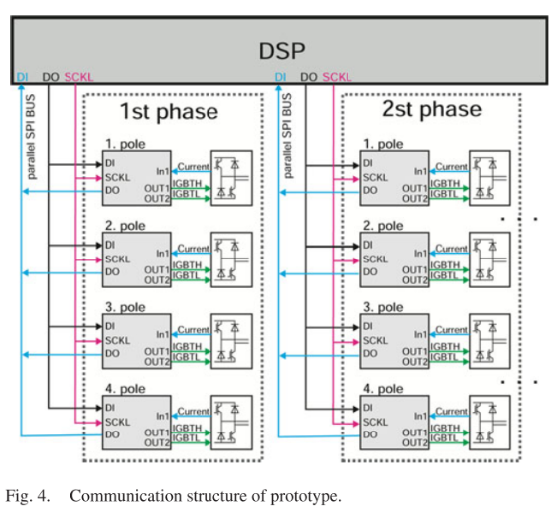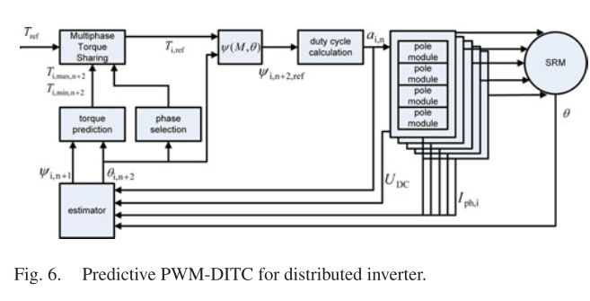

**Georges Engelmann, Maurice Kowal, Rik W. De Doncker**

Institute for Power Electronics and Electrical Drives RWTH Aachen University Aachen, Germany

*A Highly Integrated Drive Inverter using DirectFETs and Ceramic DC-Link Capacitors for Open-End Winding Machines in Electric Vehicles*

**2015**

DC-link voltage of 145V, which is extremely close to the breakdown voltage of the DirectFETs of 150V. In the nominal operating point with a dc-link voltage of 125V, a maximum efficiency of η = 97% is reached.

International Rectifier’s (IR) DirectFET technology

Thermal resistance between junction and printed circuit board (PCB) of Rth,junction-pcb < 1 ◦C/W

Junction-to-can thermal resistance Rth,junction-can = 0.25 ◦C/W

The use of ceramic dc-link capacitors is investigated because of their higher capacity density, low ESR and good capabilities for cooling.

Six phase permanent magnet synchronous machine (PMSM) with open-end windings.

Water-cooling is implemented in the housing with a maximum coolant temperature of 70 ◦C.

It is shown that a ten times higher effective capacity density of 4.35 mF/dm3 is achieved compared to equivalent foil capacitors.

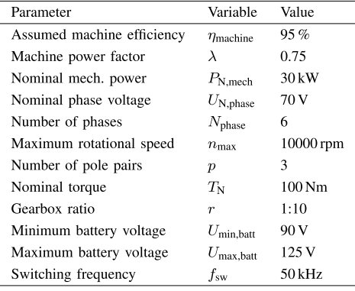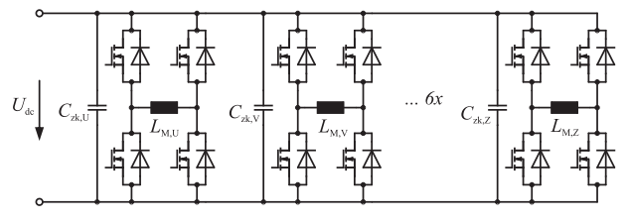

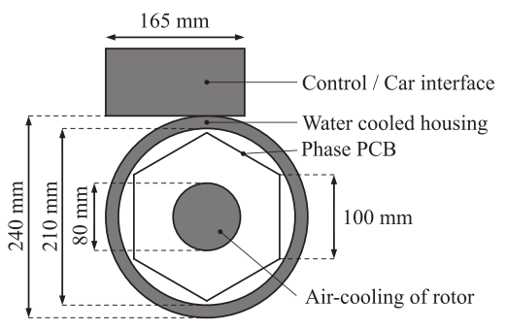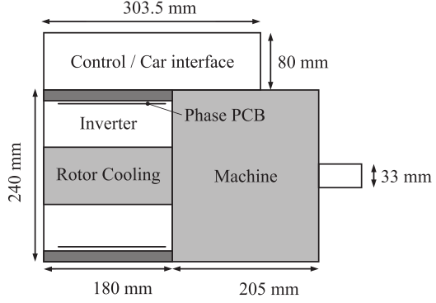

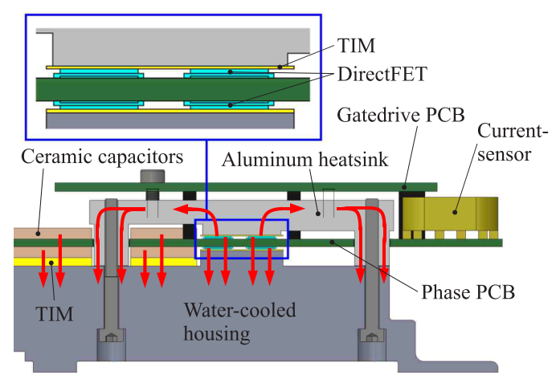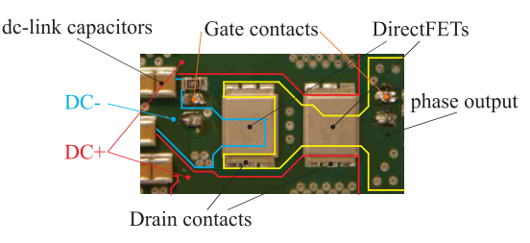

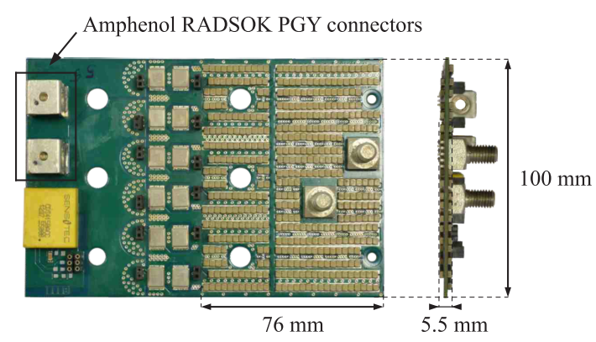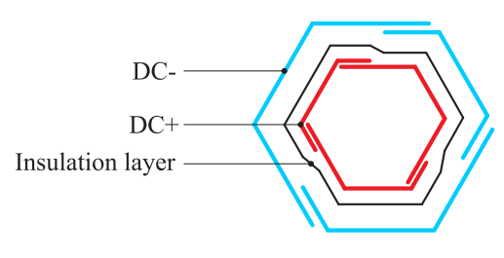

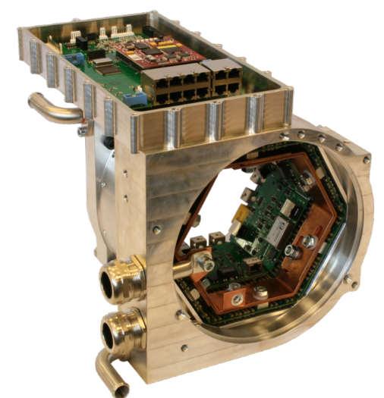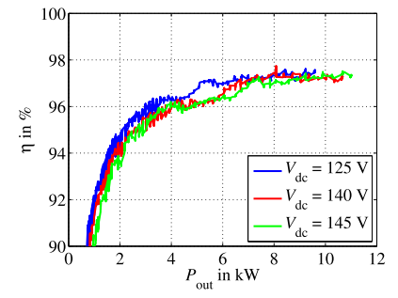

**Mehran Ektesabi and Hasib Felic**

Department of Robotics & Mechatronics, Faculty of Engineering & Industrial Sciences, Swinburne University of Technology, Australia

**2007**

Controlling Heat, Vibration and EMI in an Integral Motor

No modularization, induction motor, experimental verification

The proposed Motor is the first truly integrated motor-drive unit with a design which overcomes

heat, vibration and electromagnetic interference which are damaging to sensitive electronics.

EMI results are given, passed the tests

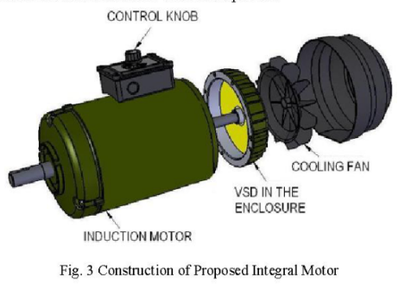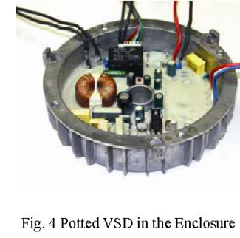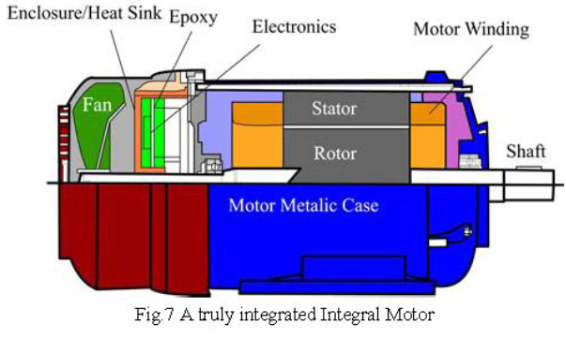

**M. Gerber, Martin Marz**

Faculty of Electrical Engineering, Mathematics and Computer Science, EWI Faculty, Delft Technical University, Delft, The Netherlands

Fraunhofer Institute of Integrated Systems and Device Technology (IISB), Erlangen, Germany

**2005**

System Integration in Automotive Power Systems

The interdependence of the electrical, the thermal and the spatial design of a system are considered and identified.

Two case studies (prototypes): engine coolents

1. 2kW automotive DC/DC converter that has a power density of 120W/in3, 14V/42V

2. Integrated drive for hybrid vehicles, IGBT

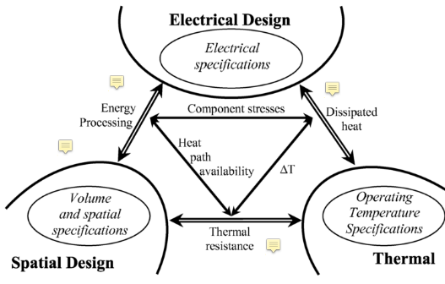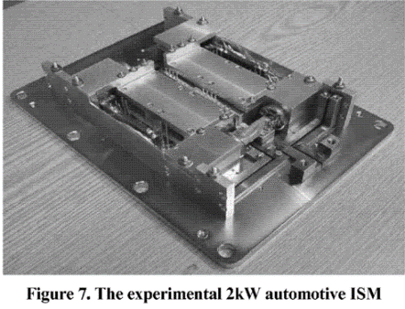

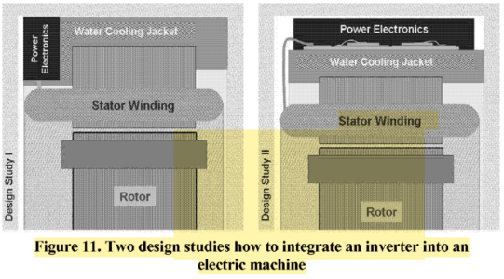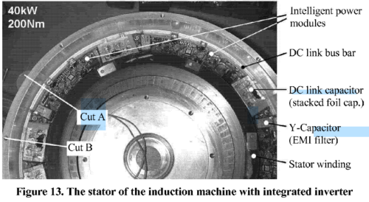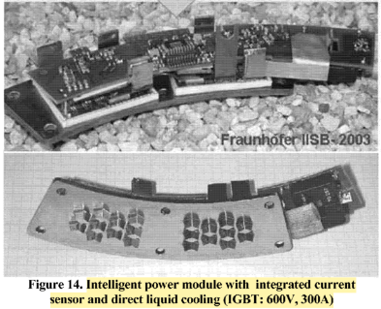

**Martin März, Andreas Schletz, Bernd Eckardt, Sven Egelkraut, Hubert Rauh**

Fraunhofer Institute of Integrated Systems and Device Technology, Erlangen, Germany

**2010**

*Power Electronics System Integration for Electric and Hybrid Vehicles*

Bir çok konuya değiniyor, daha çok evaluation makalesi

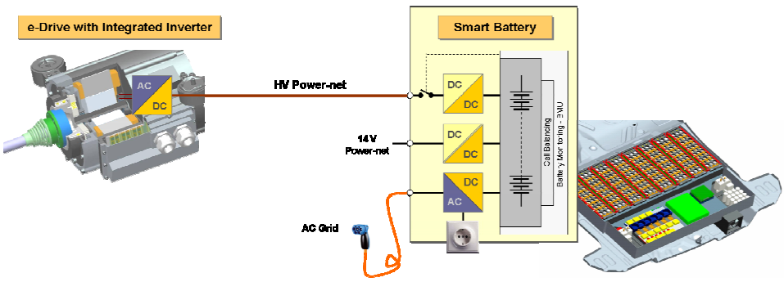

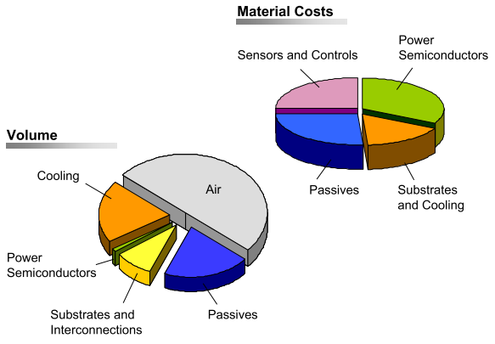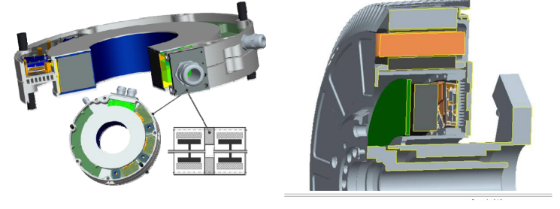

**J.J. Wolmarans*, M.B. Gerber*, H. Polinder*, S.W.H. de Haan*, J.A. Ferreira*, D. Clarenbach\*\***

*Electrical Power Processing, Delft University of Technology, Mekelweg 4, Delft, The Netherlands **Aeronamic, Plantshofweg 79, Almelo, The Netherlands

**2008**

*A 50kW Integrated Fault Tolerant Permanent Magnet Machine and Motor Drive*

An overall goal of 2kW/kg is set for system power density

A 50kW, 6 phase, 8 pole permanent magnet machine is presented with a rotor speed of 50krpm

+/-270VDC bus, as utilized in current and future new aircraft

“No single electrical fault may cause the system as a whole to stop functioning”

Simulation (mostly thermal)

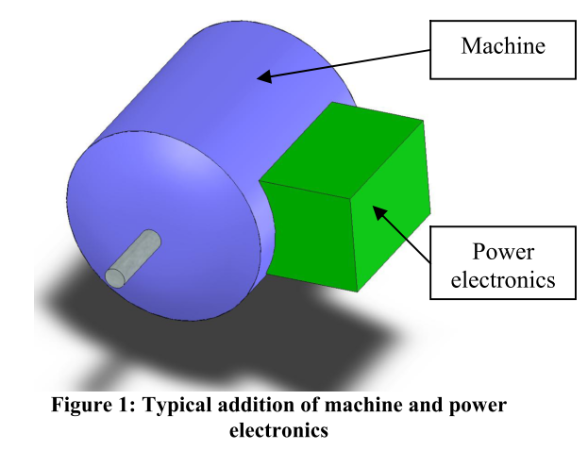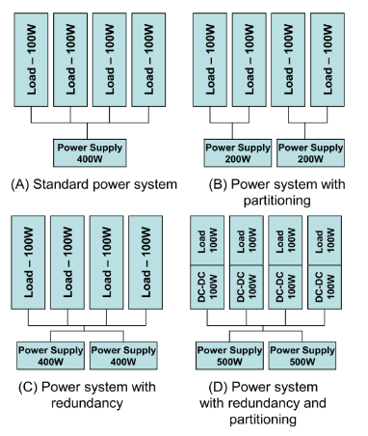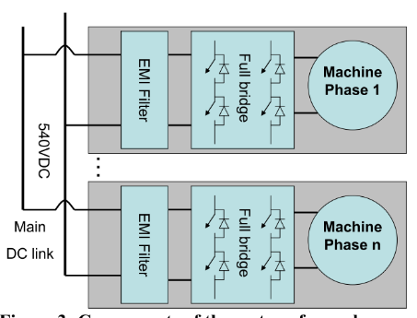

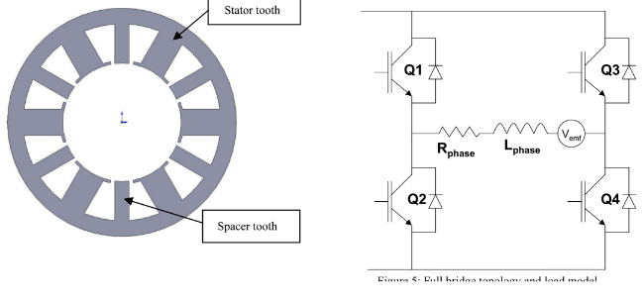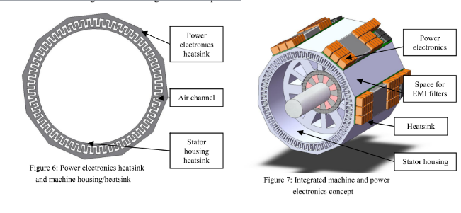

**M.Sc. Florian Ludwig, Dr.-Ing. Tobias Heidrich, PD Dr.-Ing. habil. Andreas Möckel**

Technische Universit at Ilmenau, Institute for Electric Power and Control Engineering, Ilmenau, Germany

**2015**

*Integrated high-speed PMSM Drive with IMS PCB-Technology for Mobile Applications*

xsdc

**P W Wheeler, J C Clare, L Empringham, Bradley, S Pickering, D Lampard, K J, M Apap**

University of Nottingham, School of Electrical and Electronic Engineering Nottingham, UK

University of Malta, Department of Electrical Engineering, Malta

**2005**

*A Fully Integrated 30kW Motor Drive Using Matrix Converter Technology*

Targeted at pump and fan applications, induction motor

Fully tested and evaluated demonstrations of the power converter and the cooling arrangements

30 kW prototype, power electronics housed in a re-designed End Plate, IGBT based

415 Volt, 50 Hz supply.

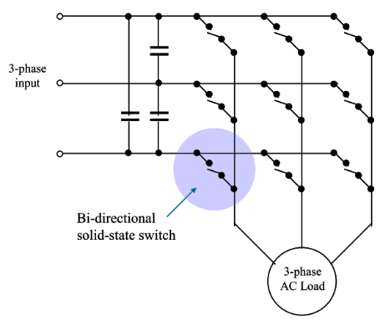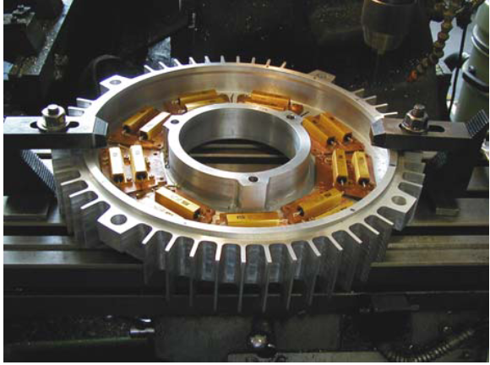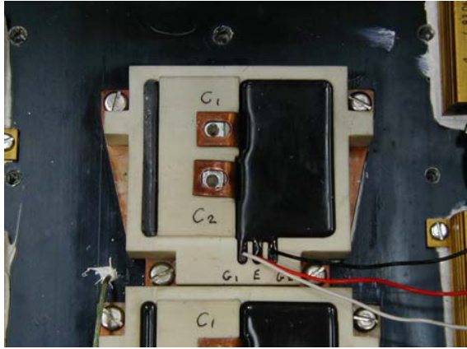

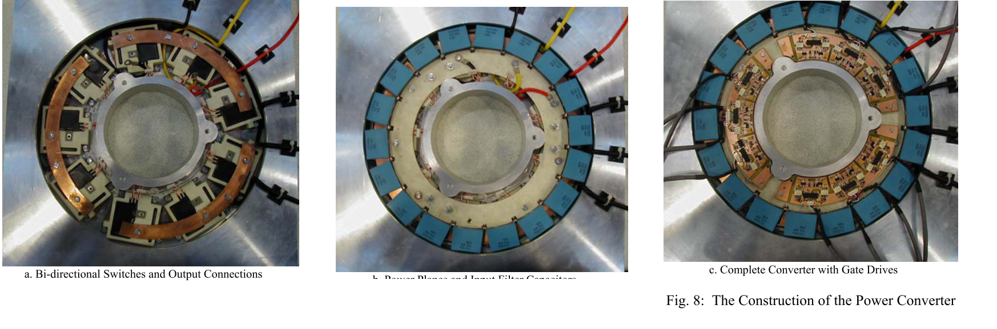

**Stephen Pickering1, Frederic Thovex1, Patrick Wheeler2, Keith Bradley2**

1School of Mechanical, Materials and Manufacturing Engrg, University of Nottingham, United Kingdom

2School of Electrical and Electronic Engineering, University of Nottingham, United Kingdom

**2006**

*Thermal Design of an Integrated Motor Drive*

Computational fluid dynamics (CFD) was used to model the ventilation and heat transfer from the new end cover and to develop improved fan geometries**.**

30 kW, 4 pole induction motor, matrix converter. Önceki makalenin termali gibi.

**Robert Abebe, Gaurang Vakil, Giovanni Lo Calzo, Tom Cox, Chris Gerada, Mark Johnson**

Department of Electrical and Electronic Engineering University of Nottingham Nottingham, UK

**2015**

*FEA Based Thermal Analysis of Various Topologies for Integrated Motor Drives (IMD)*

Mounting options for IMMD: Surface Mount Integration, End Plate Mount Integration and Stator Iron Mount Integration.

The FEA tool used was ANSYS steady state thermal analysis package. A 'full SiC' module was modelled with the switch ratings of 1200V; 60A and junction temperature 150°C. The full 3- φ power electronic module consists of 12 6x3mm SiC bare dies.

*Surface mount:* Simple mount of the converter on the machine housing or mounting modularised converter units on the housing

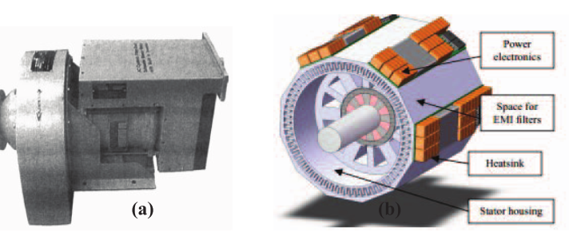

*End plate:*

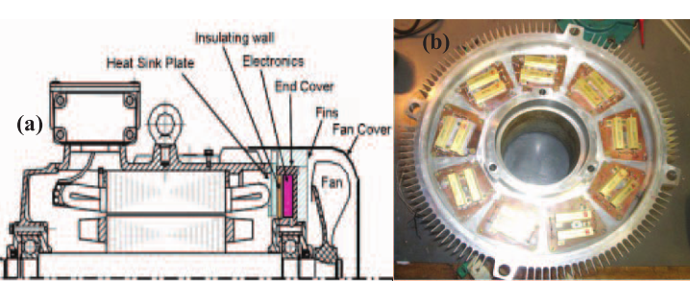

*Stator iron mount:*

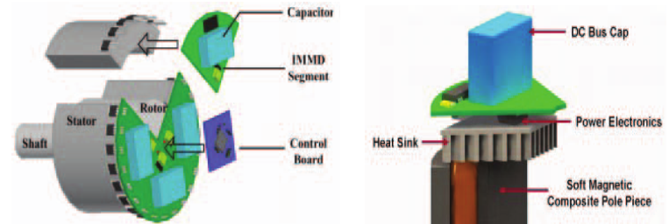

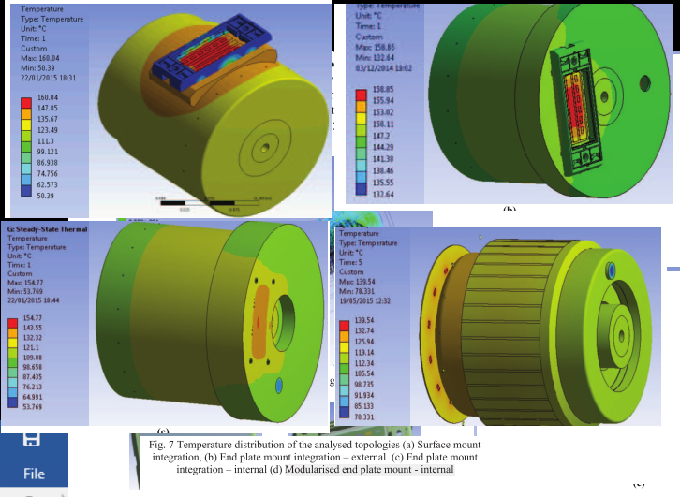

Surface mount topology:

* Effectively used the housing as the heat sink for the power module
* Proper arrangements are required to be made in order to get an effective contact between the power module and the stator casing.
* The converter and machine share a common thermal node – the machine housing. This allows for adoption of a singular cooling system for both machine and converter
* The curved housing surface makes mounting of the converter slightly complicated.

End plate mount – external configuration

* Integration of power module on the end plate is easier and the larger housing of this configuration provides better thermal distribution compared to the housing mount configuration.
* The mounting platform in the surface mounted configuration is absent in this configuration further reducing the thermal resistance between the converter and coolant.

End plate mount – internal’ configuration

* Power module is in direct contact with the coolant aiding a better thermal distribution in the IMD. This increases the heat transfer coefficient between the devices and the coolant resulting in a more efficient heat transfer.
* The motor housing acts as a heat sink for the converter further increasing temperature distribution.

The results show that the ‘modularised endplate mount’ configuration is the most effective for temperature distribution and efficient heat dissipation in the IMD system.

**Galassini, A.,** Costabeber, A., Gerada, C., Buticchi, G., & Barater, D. (**2015**). **State space model of a modular speed-drooped system for high reliability integrated modular motor drives.** *Electrical Systems for Aircraft, Railway and Ship Propulsion, ESARS*, *2015*–*May*.

**Galassini,** A., Costabeber, A., & Gerada, C. (**2015**). **Speed droop control of integrated modular motor drives**. In *IECON 2015 - 41st Annual Conference of the IEEE Industrial Electronics Society* (pp. 003271–003276). IEEE.

Lambert, S. M., Mecrow, B. C., Abebe, R., Vakil, G., & Johnson, C. M. (2015). Integrated Drives for Transport - A Review of the Enabling Thermal Management Technology. In *2015 IEEE Vehicle Power and Propulsion Conference (VPPC)* (pp. 1–6). IEEE.

Lambert, S. M., Mecrow, B. C., Abebe, R., Vakil, G., & Johnson, C. M. (2015). Integrated Drives for Transport - A Review of the Enabling Electronics Technology. *IEEE Vehicle Power and Propulsion Conference*, 1–6.

**Farhad Aghili, John M. Hollerbach, and Martin Buehler**

Canadian Space Agency, Saint-Hubert, Mechanical and Industrial Engineering Department, Concordia University, Montreal

School of Computing, University of Utah, Salt, Lake City, UT 84112 USA

Robotics, Boston Dynamics, Cambridge, MA, USA

**2007**

*A Modular and High-Precision Motion Control System with an Integrated Motor*

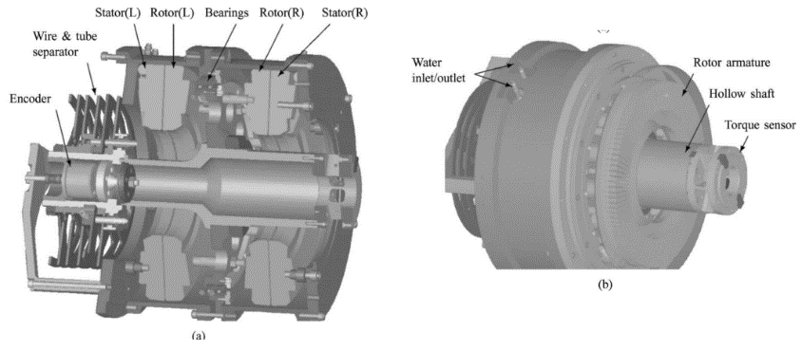

Integrated direct-drive joint, high-precision motion control

The joint integrates a direct- drive synchronous motor with axial air gap, a torque sensor, and a high-resolution position sensor.

**Gui-Jia Su and Lixin Tang**

Energy and Transportation Science Division Oak Ridge National Laboratory Knoxville

**2012**

*A Segmented Traction Drive System with a Small dc Bus Capacitor*

Electric vehicle/hybrid electric vehicle (EV/HEV)

Currently the dc bus capacitor contributes up to 20% of the cost and weight of an inverter and up to 30% of an inverter’s volume

Interleaving, simulation (PSIM), 55 kW segmented inverter prototype, IGBT, water cooled

RL load tests, reduction of 62% for capacitor ripple current and 78% for battery ripple current

Induction motor rated at 15 HP, 230 Vrms, 37.5 Arms, 91 Nm, and 1,175 rpm.

Reduction of 73% for capacitor ripple current and 89% for battery ripple current

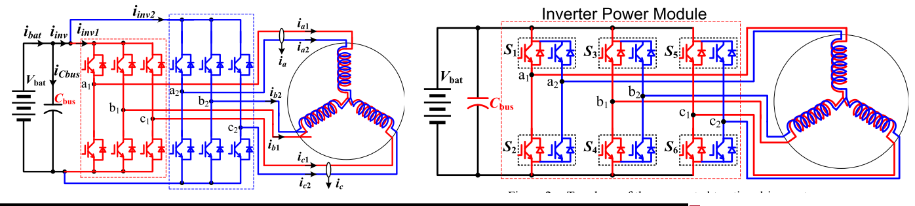

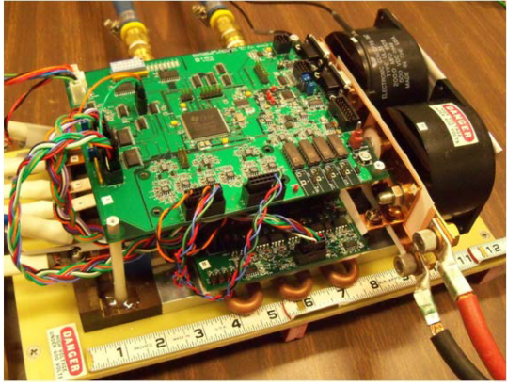

**Gui-Jia Su, Lixin Tang, Curt Ayers, and Randy Wiles**

Power Electronics and Electric Machinery Group Oak Ridge National Laboratory Knoxville, TN, USA

**2013**

*An Inverter Packaging Scheme for an Integrated Segmented Traction Drive System*

2012 yayınının integrated olanı, 55kW prototype (2 designs)

Doughnut shaped capacitors such as the Power Ring Film Capacitors with superior ripple current capabilities

Second prototype: 17.8 kW/l and specific power of 15.6 kW/kg

Resistive load bank and a commercial, off-the-shelf, induction motor rated at 15 HP (11 kW), 230 Vrms, 37.5 Arms, 91 Nm, and 1,175 rpm

The battery rms ripple current is reduced from 4.21Arms to 1.45Arms, a 66% reduction. (Resistive load)

The battery rms ripple current is reduced from 6.53Arms to 0.9Arms, an 86% reduction. (Motor load)

Because of the distributed capacitors, capacitor ripple current cannot be measured.

